
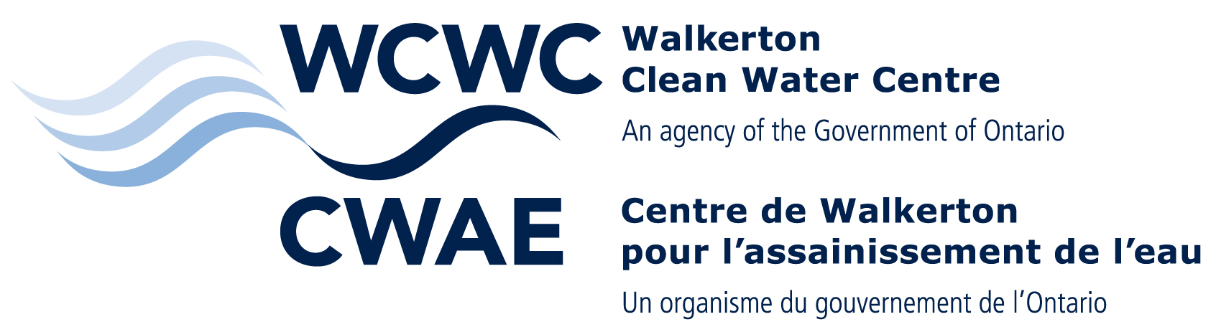
Procedure For Exam Rewrites

The following outlines the policy for exam rewrites for both of the Ministry of the Environment’s Entry-Level Drinking Water Operator and Mandatory Renewal courses.

Entry-Level Drinking Water Operator Course. The pass mark for all exams is 70%.
 | Fee | Waiting Period | Review Process  If unsuccessful
Self-Study Exam
First and Second Exam Attempt | Included as part of initial course fee | N/A | WCWC will review (by phone) areas where the examinee did poorly
Third Exam Attempt | $75.00; paid to WCWC prior to exam | None | WCWC will review (by phone) areas where the examinee did poorly
Subsequent Exam Attempts | $75.00 each exam; paid to WCWC prior to exam | (3) months or (90) days for each subsequent exam rewrite | WCWC will review (by phone) areas where the examinee did poorly
Classroom Exam
First Exam Attempt | Included as part of initial course fee | N/A | WCWC will notify examinee of failure (by mail) and refer to OCWA. OCWA will review (by phone) areas where the examinee did poorly.
Second and Third Exam Attempt | $75.00; paid to WCWC prior to exam | None | OCWA will review (by phone) areas where the examinee did poorly
Subsequent Exam Attempts | Participant must retake the classroom portion of the course. Contact WCWC.
NOTE: REGISTRANT HAS ONE YEAR FROM THE DATE OF THE FIRST EXAM ATTEMPT IN THE CLASSROOM TO PASS THE EXAM. AFTER ONE YEAR A PERSON MUST REGISTER TO ATTEND THE CLASSROOM PORTION OF THE COURSE AGAIN.
Mandatory Renewal Course. The pass mark for all exams is 70%.
Classroom Exam
 | Fee | Waiting Period | Review Process if unsuccessful
First Exam Attempt | Included as part of initial course fee | N/A | WCWC will notify examinee of failure (by mail) and refer to OCWA. OCWA will review (by phone) areas where the examinee did poorly
Second and Third Exam Attempt | $75.00; paid to WCWC prior to exam | None | OCWA will review (by phone) areas where the examinee did poorly
Subsequent Exam Attempts | Participant must retake the course and pay the applicable fee. Contact WCWC.
Correspondence Exam (Hand-in Questions)
First Exam Attempt | Included as part of initial course fee | N/A | OCWA will review (by phone) areas where the examinee did poorly
Second Exam Attempt | Included as part of initial course fee | N/A | OCWA will review (by phone) areas where the examinee did poorly
Subsequent Attempts | Participant must retake the course and pay the applicable fee. Contact WCWC.

